Summary report

8th Strategy Forum of the EUSBSR in Berlin 13 – 14 June

Seminar: Climate Challenges for Energy Supply

Time: Tuesday, 13 June, 17:00 to 18:30 hours, Lesehof

The seminar “Climate Challenges for Energy Supply” was jointly organized by Council of the Baltic Sea States, coordinator of HA Climate; Latvian Ministry for Economics, coordinator of PA Energy; Swedish Civil Contingency Agency, Coordinator of PA Secure and by Baltic Development Forum. More than 60 participants attended the seminar.
Seminar participants discussed different aspects of EU joint climate and energy policy implementation and representatives of policy makers, business and academia addressed key problems caused by the climate change to energy supply and discussed how climate resilient technology and improved interconnections ensure affordable and secure supply of carbon neutral energy to the Baltic Sea Region.
Key-note speakers and panelists were Krista Kampus, Senior Advisor of CBSS; Dzintars Kauliņš, Director of Renewable Energy and Energy Efficiency Department, Ministry of Economics of Latvia; Krzysztof Laskowski; Advisor on Climate of EURELECTRIC; Hilde Marit Kvile, Senior Advisor of Nordic Energy Research; Ida Kullgren, Risk Officer of Värmland County Administrative Board, Sweden and Jacek Paszkowski, Advisor to CBSS.
Seminar panelists concluded that complex problems related to increasing the resilience against negative impacts of long-term climate change could be solved effectively only in close cooperation of relevant sectors and with engagement of major stakeholder groups.
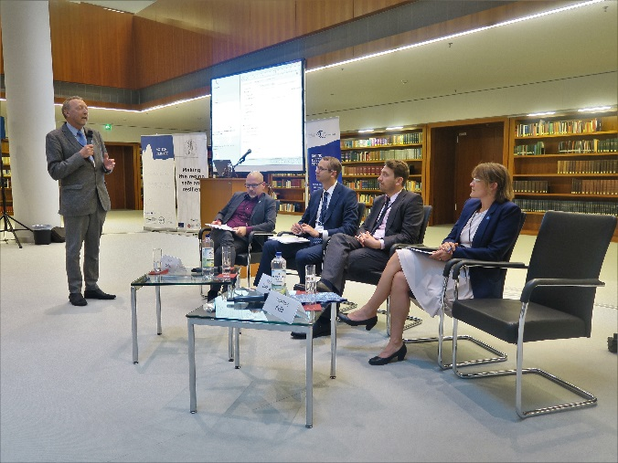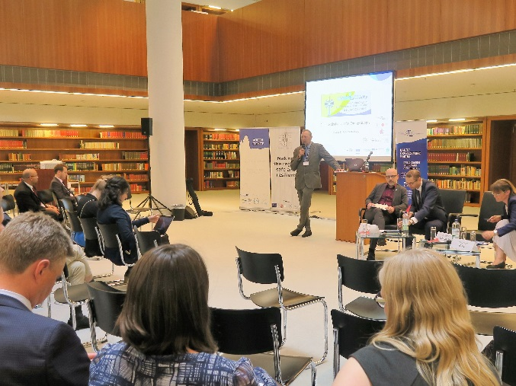
Photos Andriy Martynenko

